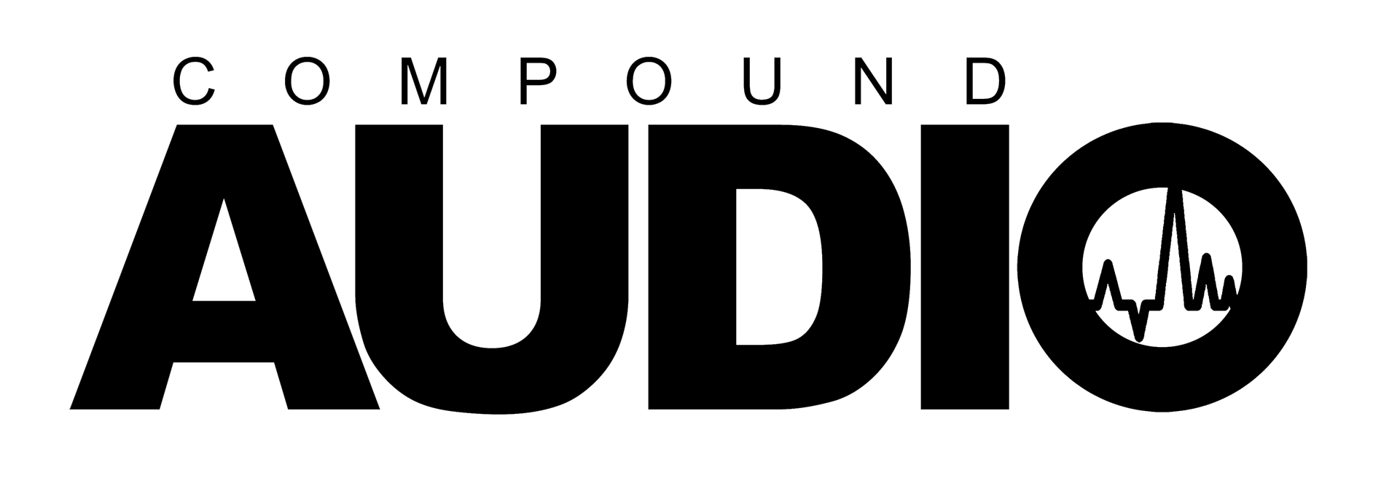
Help us see your audio vision by filling out this form.

ARTIST / LABEL NAME:  Your Name / Your Label | CONTACT NAME & EMAIL:  Your Name & Email
DEADLINE DATE: | ISRC #  (Optional)
ARTIST & TRACK TITLE(S):
Track 1.
Track 2.

MASTERING NOTES / SPECIAL REQUIREMENTS / LINKS TO REFERENCE TRACKS

“Please give as much detail as possible, If we do not receive instructions the engineer will master as he thinks is appropriate.”

Privacy Policy | Terms
V2.0

